# Criteria B (Design)

# 1. Test Plan

|  |  |  |  |
| --- | --- | --- | --- |
| # | Test Description | Input Data | Expected Result |
| 1 | User can register and login | **Normal**: Enter valid username and password  **Extreme**: Enter very long username/password  **Abnormal**: Enter invalid credentials | Account created and logged in successfully  Account created with truncated data if necessary  Error message displayed |
| 2 | Admin can create and manage users | **Normal:** Add a new user with valid credentials  **Extreme:** Add a very long username or email  **Abnormal:** Leave required fields empty | User created successfully  Truncation applied if necessary  Error message displayed for missing inputs |
| 3 | User can add new orders | **Normal:** Enter valid order details  **Extreme:** Add an order with many items  **Abnormal:** Leave required fields empty | Order saved successfully  System handles large input sets correctly  Error message displayed for missing details |
| 4 | System displays daily order summary | **Normal:** Access daily orders page  **Extreme:** Large number of orders  **Abnormal:** No orders for the day | Orders displayed correctly  System handles high order volume efficiently  "No orders found" message displayed |
| 5 | Staff can search and edit orders | **Normal:** Search by order ID or customer name  **Extreme:** Search for a large number of results  **Abnormal:** Search for a non-existing order | Relevant orders displayed  System handles large result sets efficiently  "No orders found" message displayed |
| 6 | The system calculates and tracks income | **Normal:** Enter valid orders with different prices  **Extreme:** Large order values  **Abnormal:** Enter non-numeric values in price fields | Total income correctly calculated  Handles large values efficiently  Error message displayed for invalid input |
| 7 | System generates reports for deliveries | **Normal:** View delivery report for a specific date  **Extreme:** Large number of deliveries  **Abnormal:** No deliveries for the selected date | Report generated correctly  Handles high volume smoothly  "No deliveries found" message displayed |
| 8 | Security features function correctly | **Normal:** Attempt login with correct credentials  **Extreme:** Attempt brute-force login  **Abnormal:** Attempt login with invalid credentials | Login successful with valid credentials  Brute-force protection activated  Access denied for incorrect credentials |
| 9 | System backups data regularly | **Normal:** Perform manual backup  **Extreme:** Large database backup  **Abnormal:** Backup fails due to storage issues | Backup completed successfully  Handles large data efficiently  Error message displayed for storage issues |

# 2. Entity Relationship Diagram

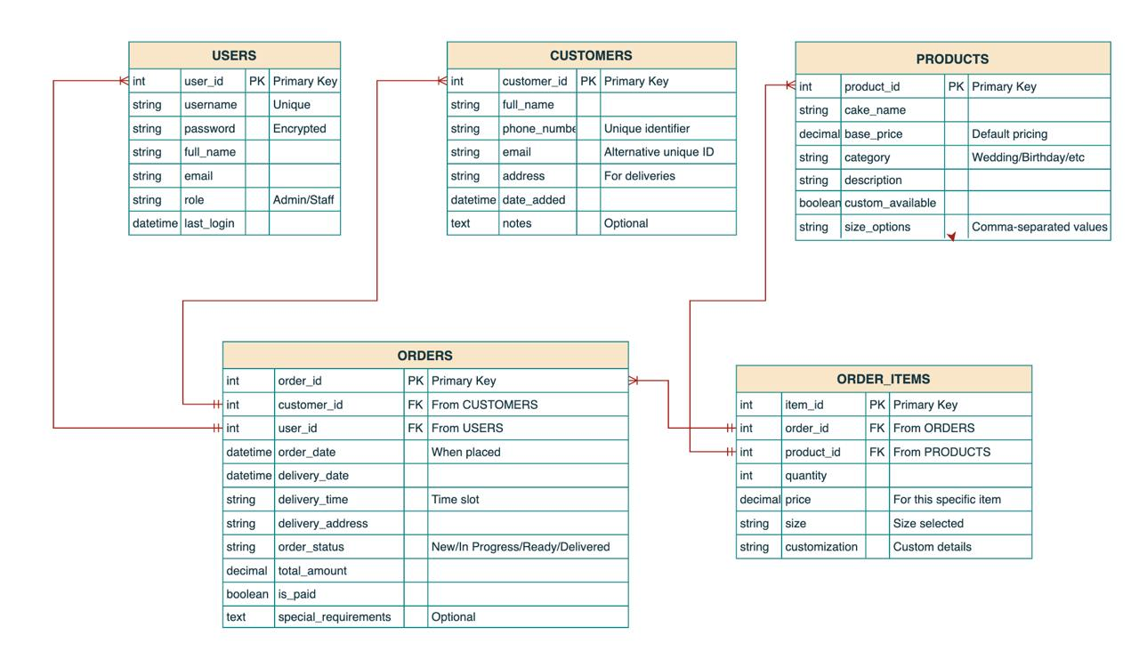

# 3. Tables Showing Fields and Data Types

**Table: USERS**

|  |  |  |  |
| --- | --- | --- | --- |
| **Field Name** | **Data Type** | **Description** | **Other Information** |
| user_ID | AutoNumber | Uniquely identifies user | Primary Key |
| Username | Text | Username for login | Must be unique |
| password | Text | Password for login | Must be encrypted for security |
| full_name | Text | Full name of the user |  |
| email | Text | Email address of the user |  |
| role | Text | Role of the user | Defines access privileges |
| last_login | Date/Time | Last time the user logged in |  |

**Table: CUSTOMERS**

|  |  |  |  |
| --- | --- | --- | --- |
| **Field Name** | **Data Type** | **Description** | **Other Information** |
| customer_ID | AutoNumber | Uniquely identities the customer | Primary Key |
| full_name | Text | Full name of the customer |  |
| phone_number | Text | Phone number of the customer | Used as unique identifier |
| email | Text | Email address of the customer | Alternative unique identifier |
| address | Text | Physical address of the customer | For deliveries |
| date_added | Date/Time | When the customer was added to system |  |
| notes | Memo | Additional information about customer | Optional |

**Table: PRODUCTS**

|  |  |  |  |
| --- | --- | --- | --- |
| **Field Name** | **Data Type** | **Description** | **Other Information** |
| product_ID | AutoNumber | Uniquely identities the cake product | Primary Key |
| cake_name | Tetx | Name of the cake |  |
| base_price | Currency | Base price of the cake | Default pricing |
| category | Tetx | Category of cake (Wedding/Birthday/etc.) |  |
| description | Text | Description of the cake |  |
| custom_available | Yes/No | Whether customization is available |  |
| size_options | Text | Available size options | Comma-separated values |

T**able: ORDERS**

|  |  |  |  |
| --- | --- | --- | --- |
| **Field Name** | **Data Type** | **Description** | **Other Information** |
| order_ID | AutoNumber | Uniquely identifies the order | Primary Key |
| customer_ID | Number | ID of customer who places order | Foreign Key from CUSTOMERS |
| user_ID | Number | ID of user who entered the order | Foreign Key from USERS |
| order_date | Date/Time | Date when order was placed |  |
| delivery_date | Date/Time | Date for cake delivery |  |
| delivery_time | Text | Time slot for delivery |  |
| delivery_address | Text | Address for delivery |  |
| order_status | Text | Status of order | (New/In Progress/Ready/Delivered) |
| total_amount | Currency | Total cost of order |  |
| is_paid | Yes/No | Whether order is paid |  |
| special_requirements | Memo | Special notes for order |  |

**Table:ORDER_ITEMS**

|  |  |  |  |
| --- | --- | --- | --- |
| **Field Name** | **Data Type** | **Description** | **Other Information** |
| item_ID | AutoNumber | Uniquely identifies the order item | Primary Key |
| order_ID | Number | ID of the order | Foreign Key from ORDERS |
| product_ID | Number | ID of the product ordered | Foreign Key from PRODUCTS |
| quantity | Number | Quantity of cakes ordered |  |
| price | Currency | Price for this specific item |  |
| size | Text | Size selected for cake |  |
| customization | Text | Custom details for cake |  |

**4. Proposed Queries**

|  |  |  |
| --- | --- | --- |
| **Query** | **Purpose** | **Additional** |
| **qryTomorrowsOrder** | List of all orders scheduled for delivery tomorrow | Essential for staff preparation |
| **qryOrderDetails** | Retrieve complete details of an order including customer information and order items | Used for order management |
| **qryCustomerOrders** | View all orders placed by a specific customer | Helps with customer relationship management |
| **qryMonthlyIncome** | Calculate total income per month | For financial tracking and seasonal trend analysis |
| **qryDailyDeliveries** | List all deliveries scheduled for a specific date | Used by delivery team |
| **qryLowStock** | Identify ingredients that need to be restocked | Ensures preparation materials are available |
| **qryPopularProducts** | Identify most ordered cake types | Helps with inventory planning and marketing |
| **qryPendingPayments** | List all orders that haven't been paid yet | For financial follow-up |
| **qryUserActivity** | Track order entry activity by staff | For performance monitoring |

# 5. Mock-ups

## 5.1 Login Page

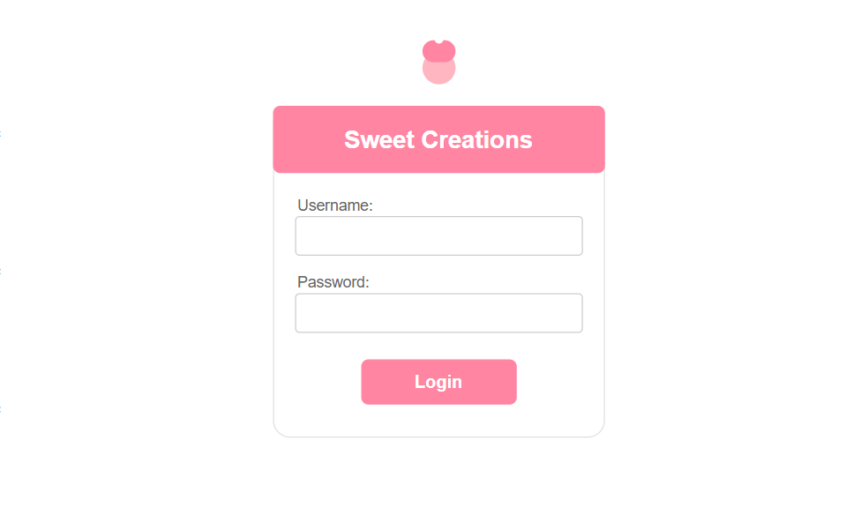

## 5.2. Dashboard

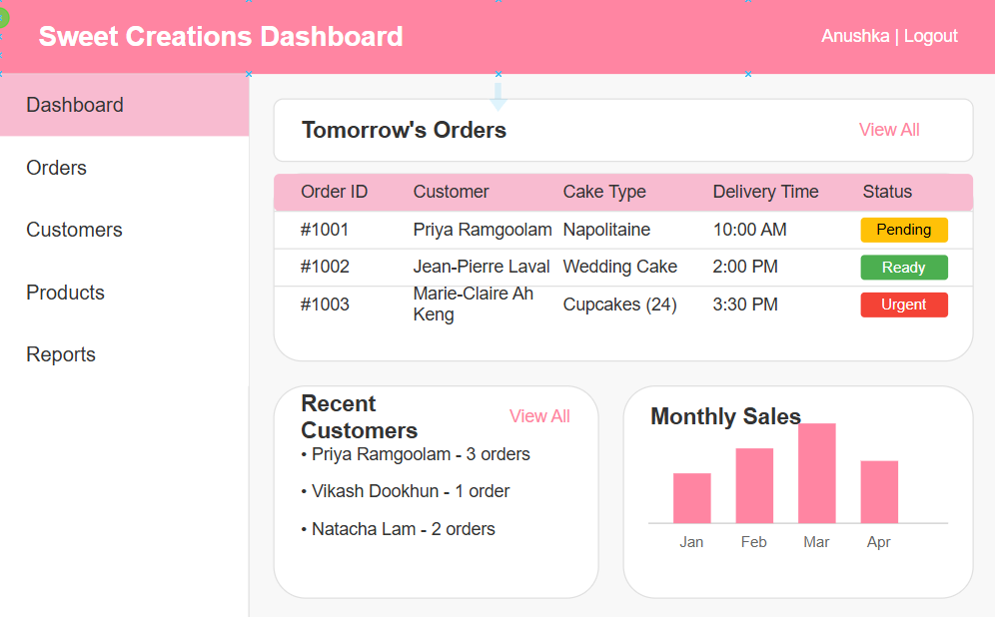

## 5.3. Order Form

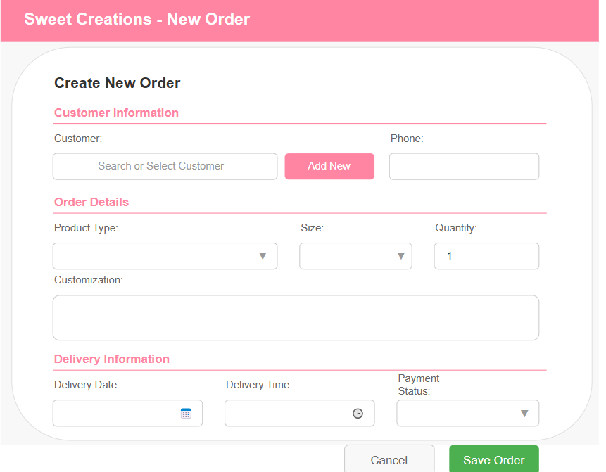

# 6. Flowcharts

## 6.1 Login Flow

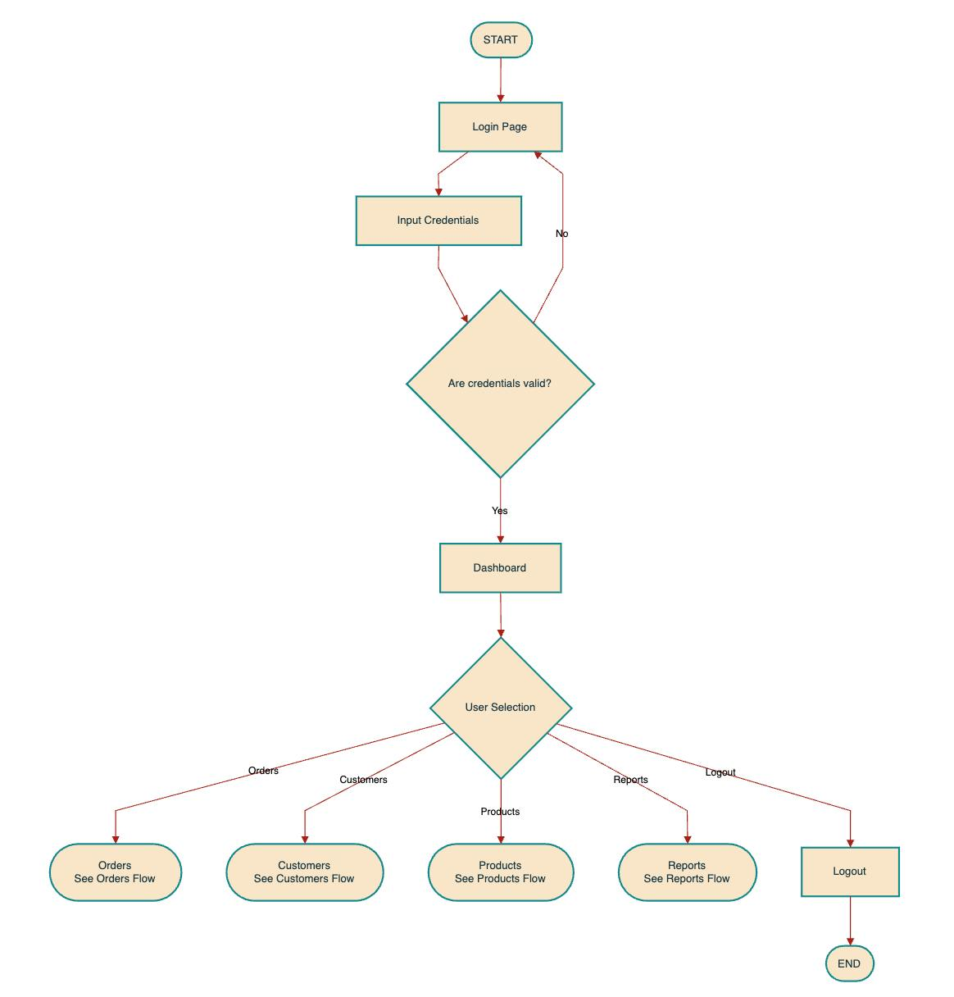

## 6.2 Orders Flow

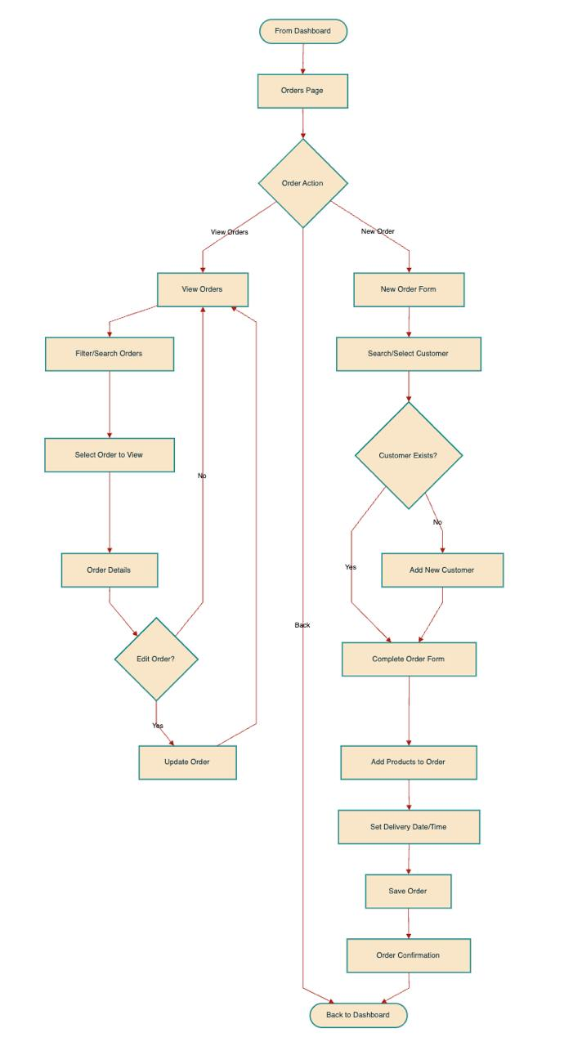

## 6.3 Customers Flow

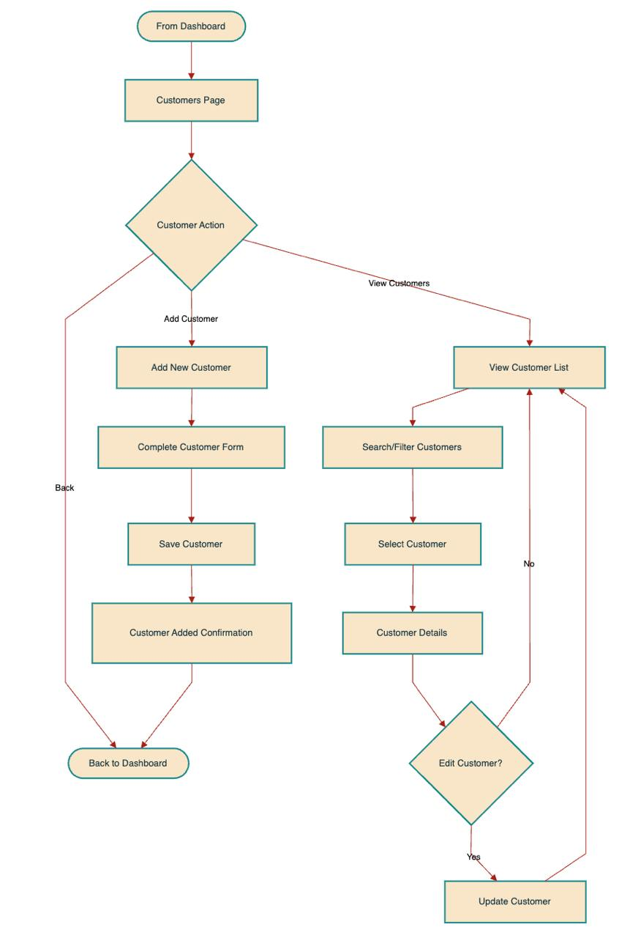

## 6.4 Products Flow

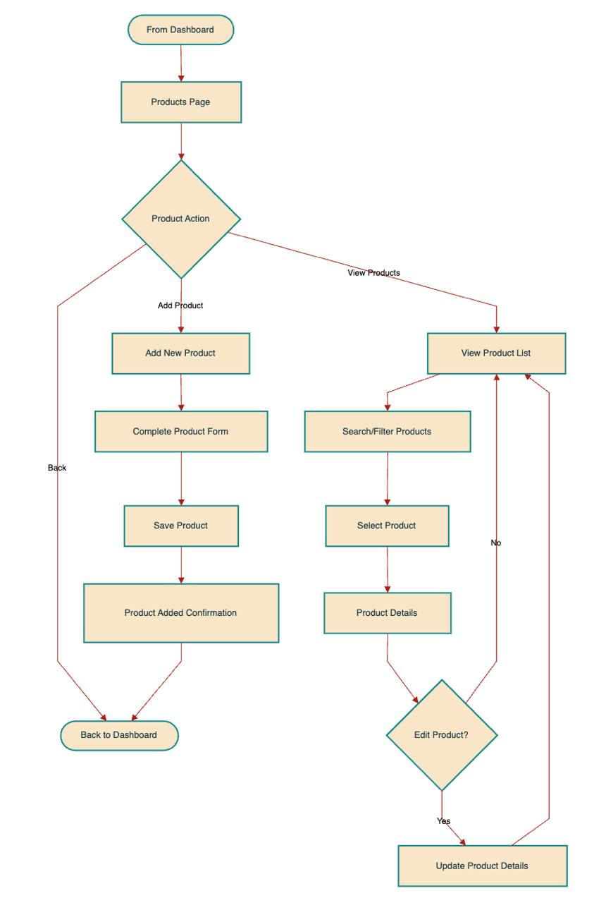

## 6.1 Reports Flow

